Front End Development

Advance Javascript

Introduction And Code Quality

Q 1:- Write a program to Show an alert.

Ans:-

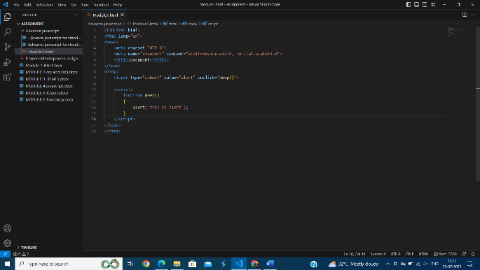

Q 2:- What will be the result for these expressions?

(1) 5>4 Ans :- True

(2) "apple" > "pineapple". Ans :- False

(3) "2" > "12". Ans :- True

(4) undefined == null Ans :- True

(5) undefined === null Ans :- False

(6) null == "\n0\n" Ans :- False

(7) null === +"\n0\n" Ans :- False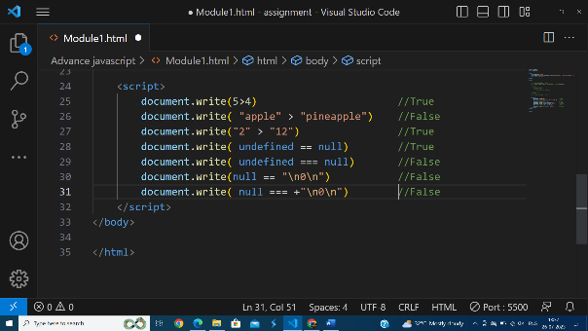

Q 3:- Will alert be shown?

if ("0") { alert( 'Hello'); }

Ans :- yes

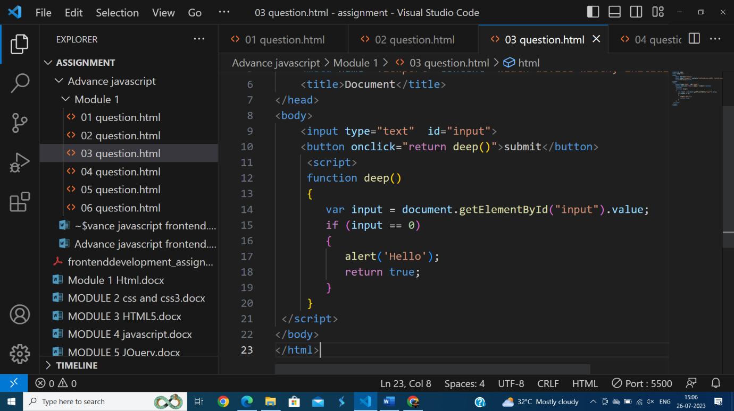

Q 4:- What is the code below going to output?

alert( null || 2 || undefined );

Ans :-

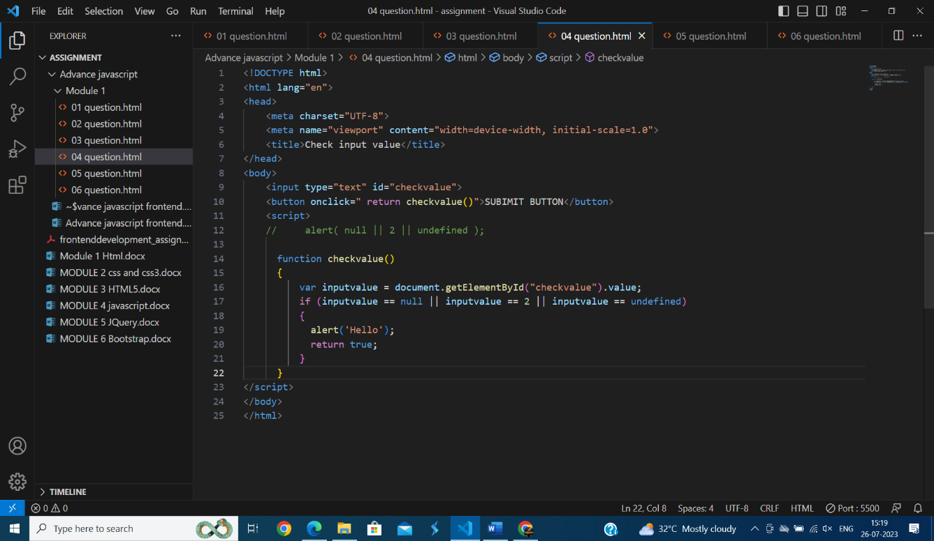

Q 5:- The following function returns true if the parameter age is greater than 18. Otherwise it asks for a confirmation and returns its result:

function checkAge(age)

{

if (age> 18) { return true; }

else {

// ...return confirm (‘did parents allow you?');

}

}

Ans :-

––––––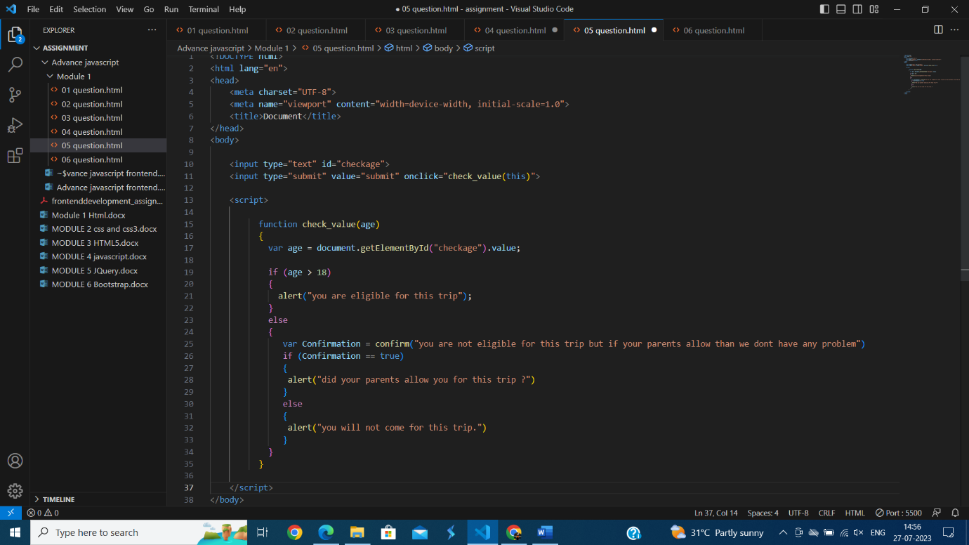

Q 6:- Replace Function Expressions with arrow functions in the code below: Function ask(question, yes, no).

Ans :-

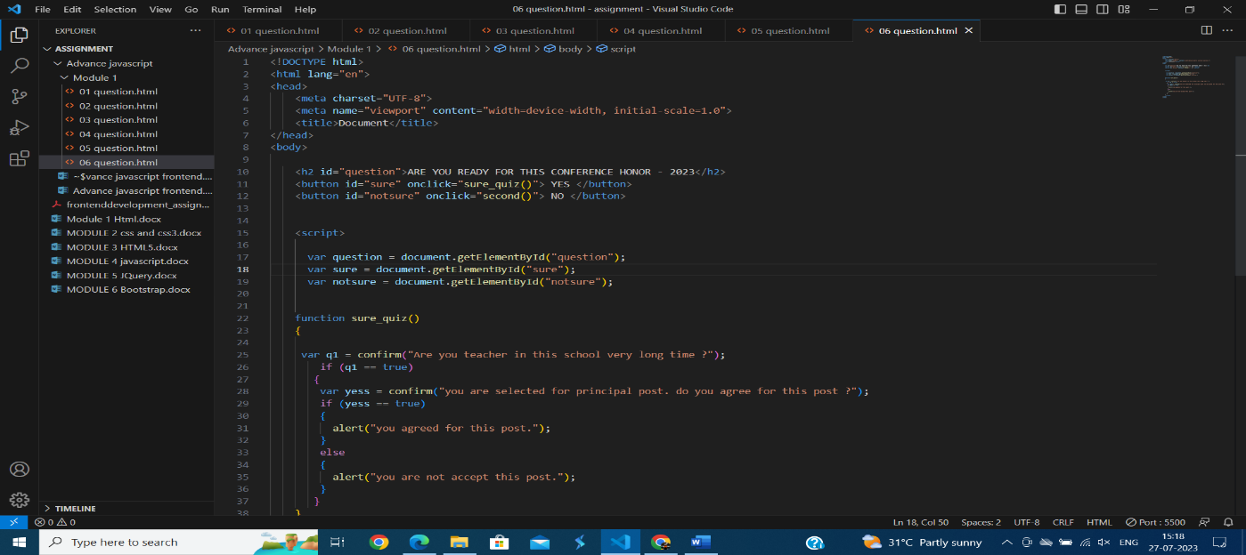

Data Type And Object

Q 1:- Write the code, one line for each action.

(a) Create an empty object user.

Ans :-

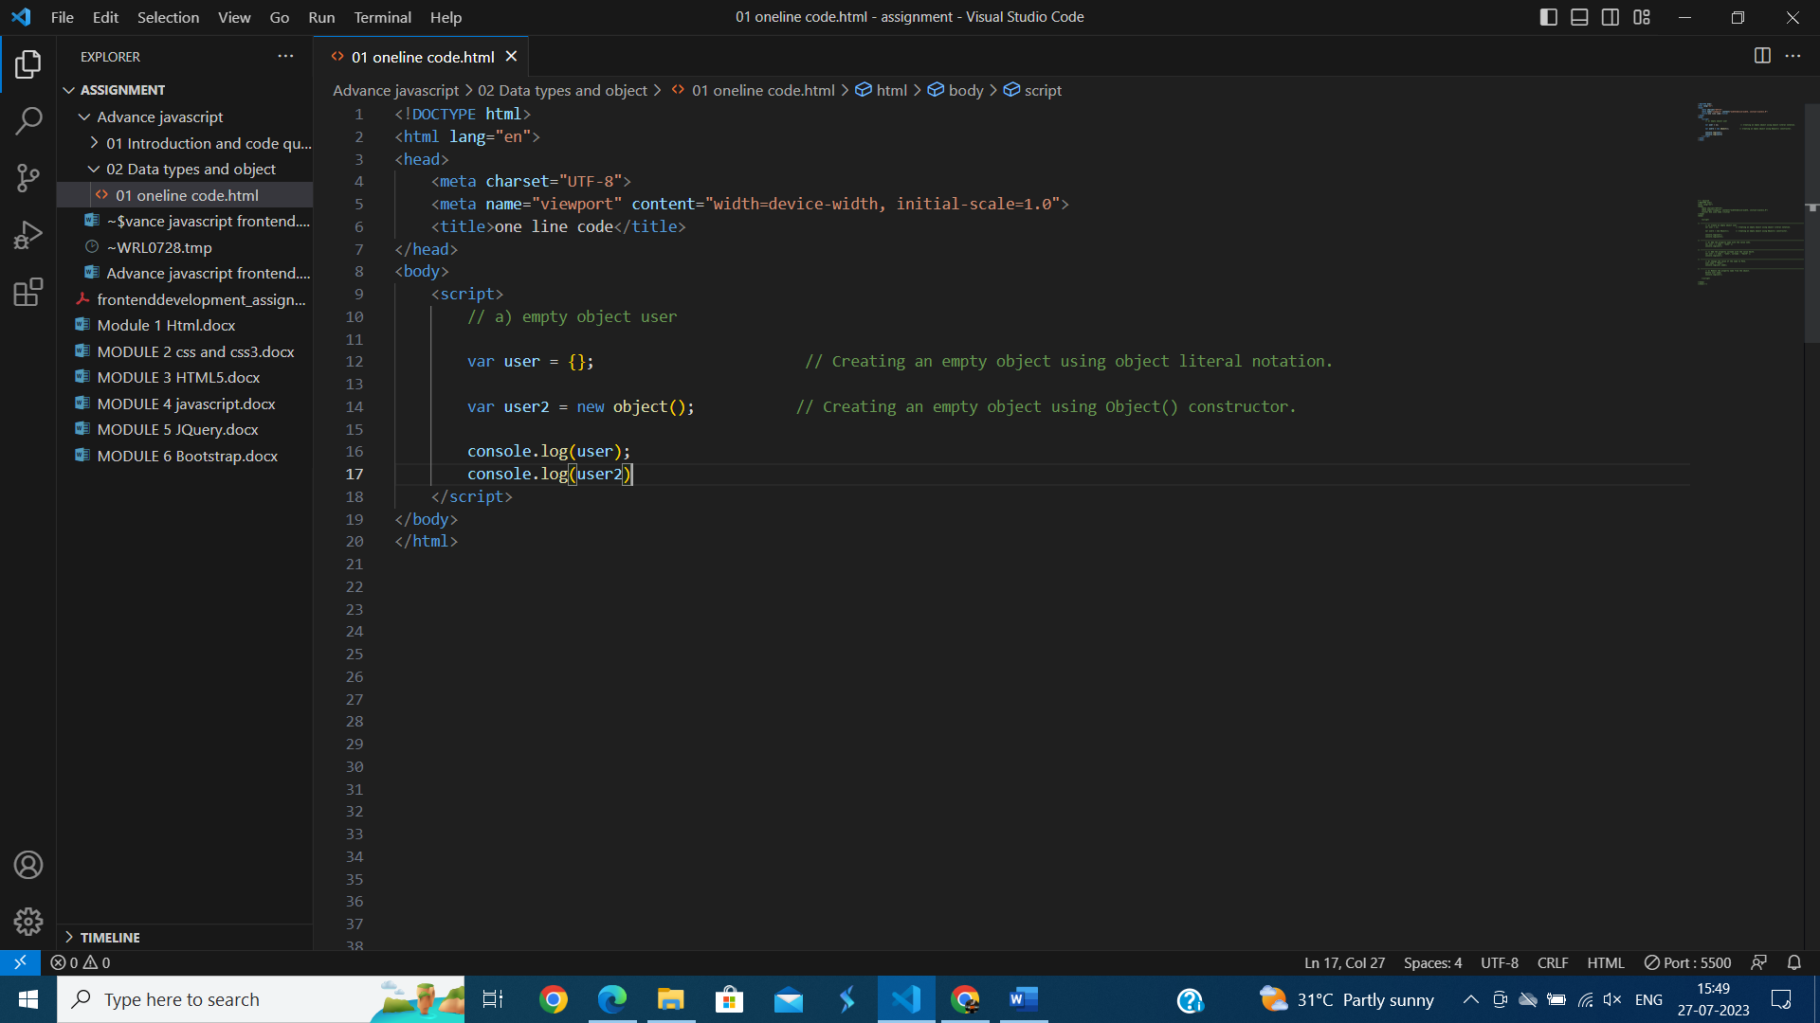

(b) add the property name with the value john.

Ans :-

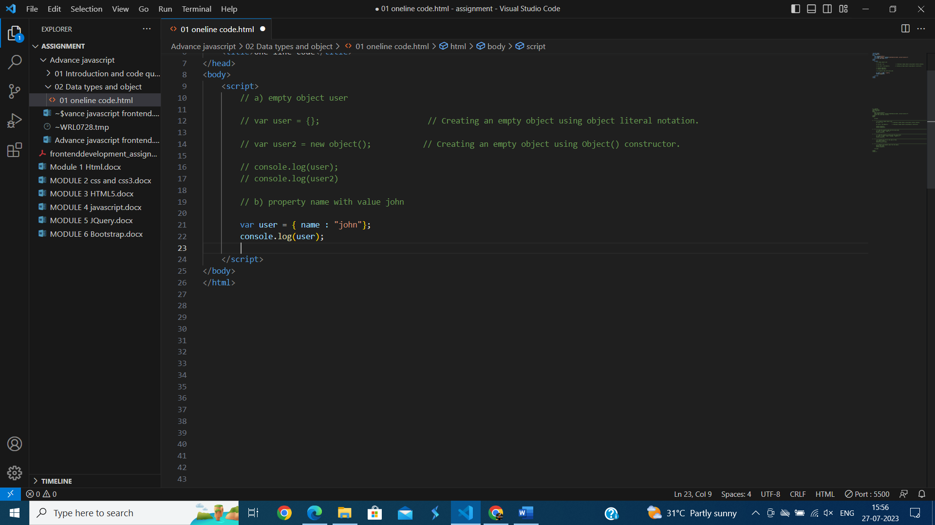

(c) Add the property surname with the value smith.

Ans :-

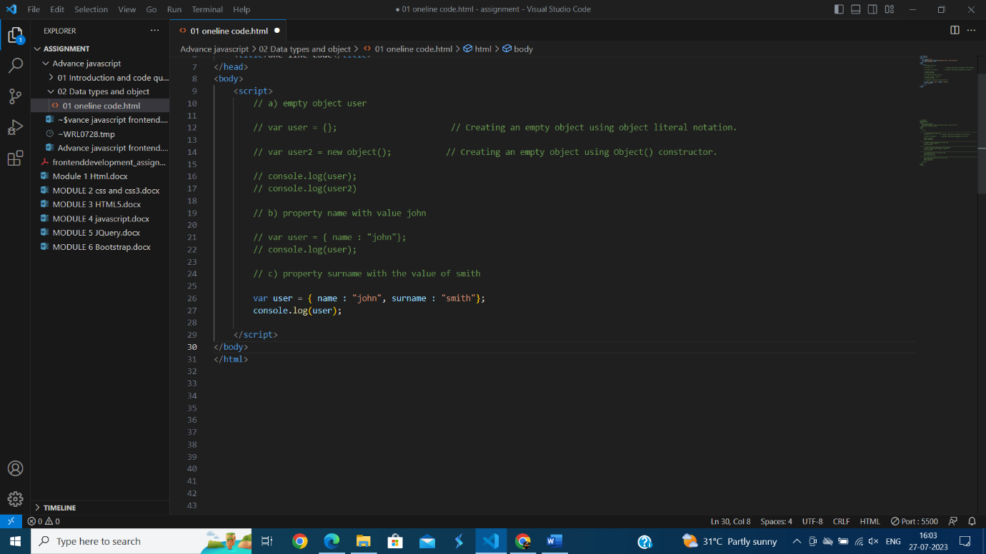

(d) Change the value of the name to pete.

Ans :-

(e) Remove the property name from the object.

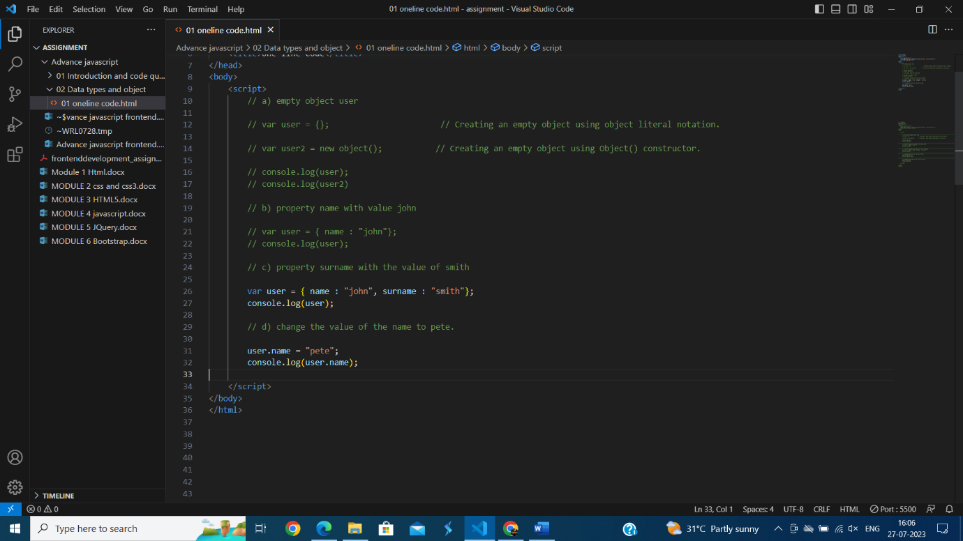Ans :-

Q 2 :- Is array copied?

Ans :-

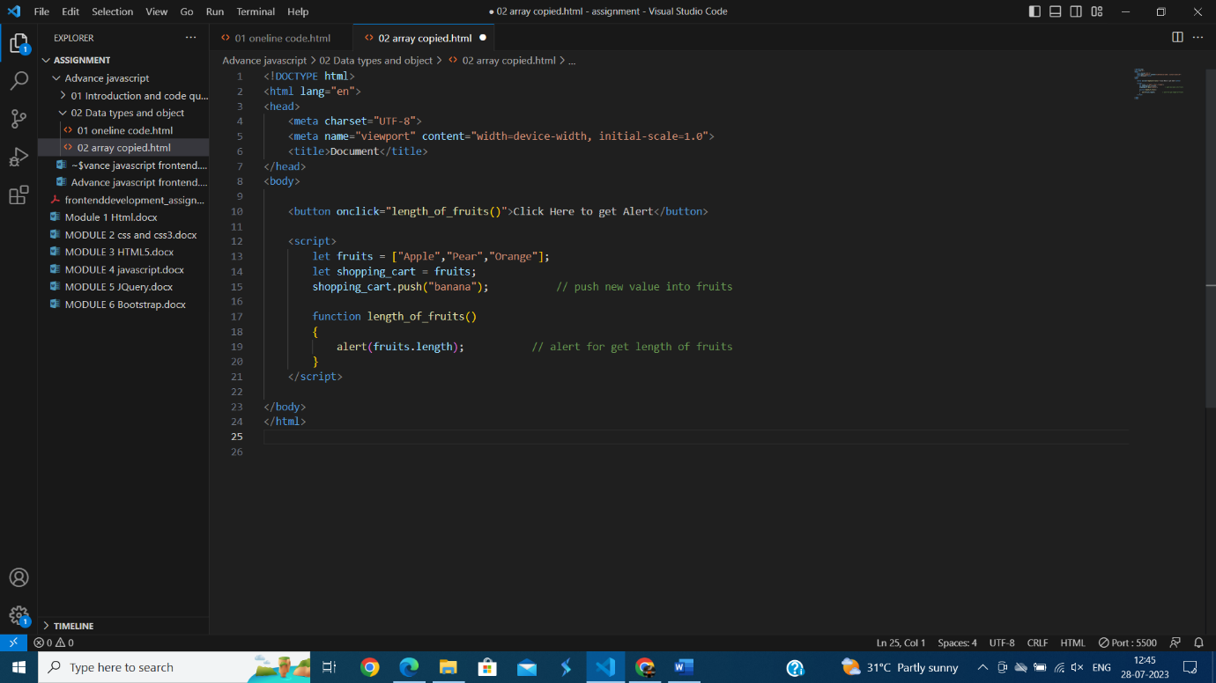

Q 3:- Map to names

Ans :- 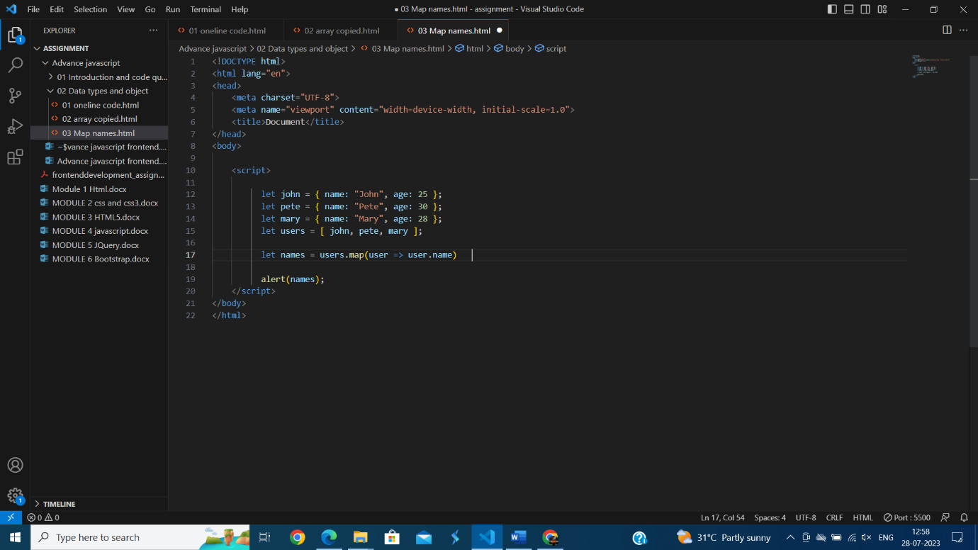

Q 4:- Map to objects .

Ans :-

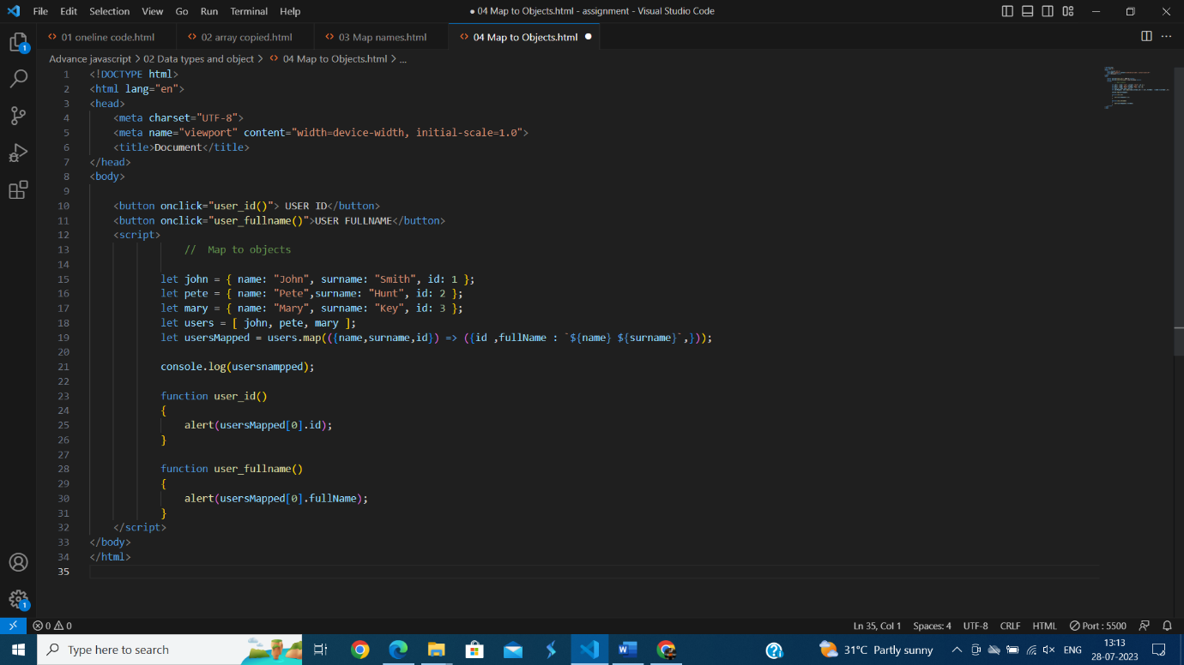

Q 5:- Sum the properties There is a salaries object with arbitrary number of salaries. Write the function sumSalaries(salaries) that returns the sum of all salaries using Object.values and the for..of loop.If salaries is empty, then the result must be 0.

Ans :-

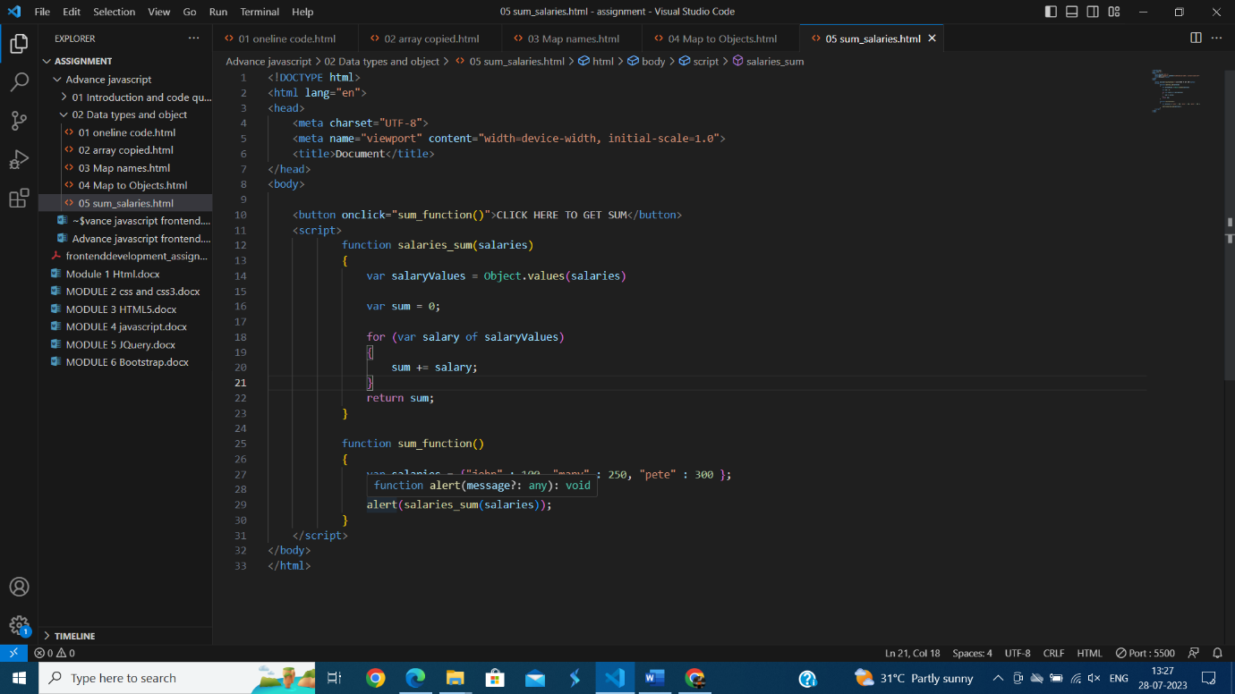

Q 6:- Destructuring assignment We have an object: Write the Destructuring assignment that reads:

a) Name property into the variable name.

b) Years property into the variable age.

c) isAdmin property into the variable isAdmin (false, if no such property)

d) let user = { name: "John", years: 30};

Ans :-

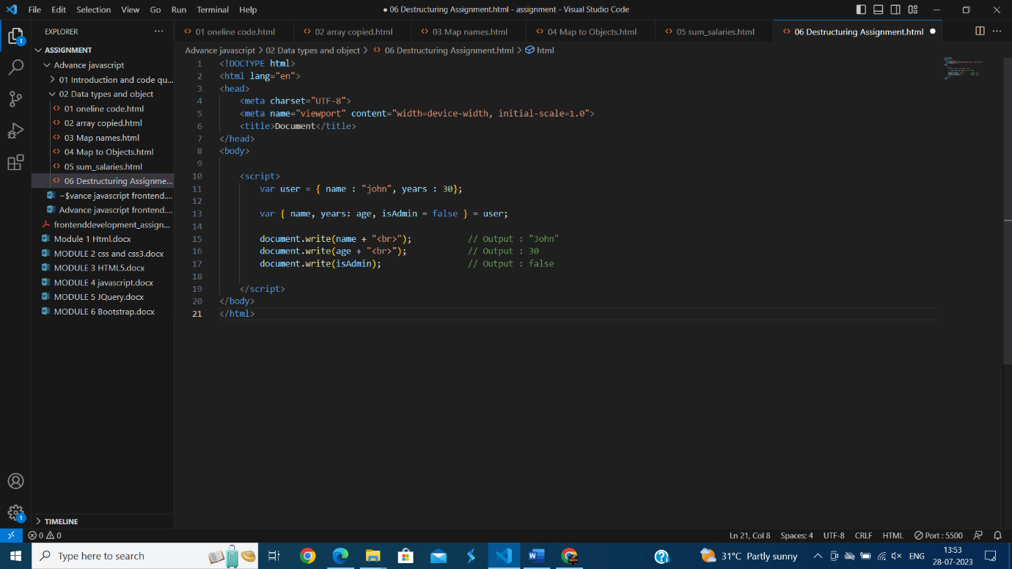

Q 7:- Turn the object into JSON and back Turn the user into JSON and then read it back into another variable.

Ans :-

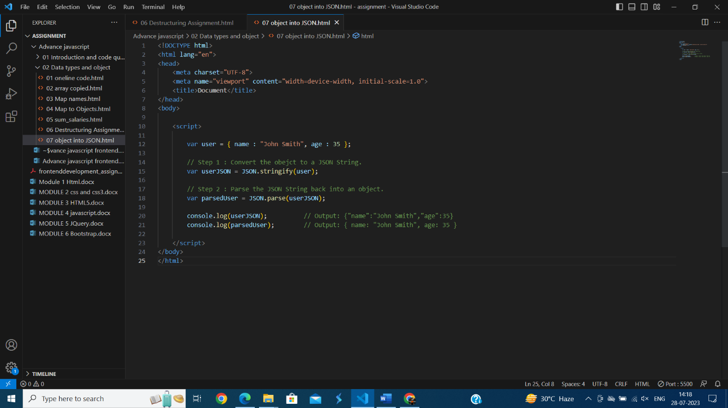

DOCUMENT EVENT AND CONTROLS

Q 1:- Create a program to hide/show password.

Ans :-

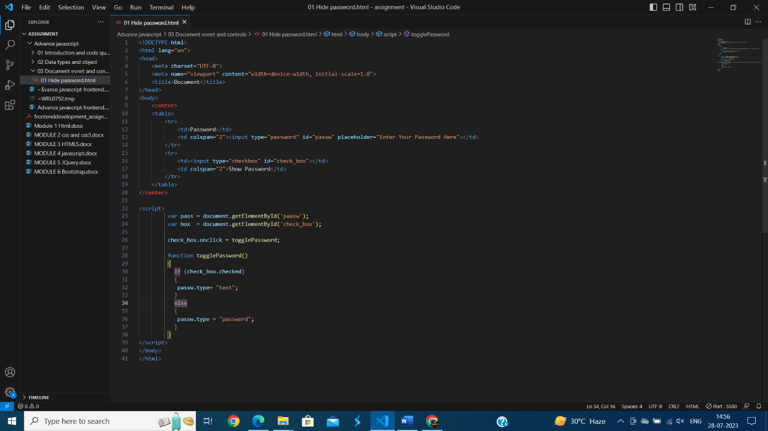

Q2 :- Create a program that will select all the classes and loop over and whenever i click the button the alert should show.

Ans :-

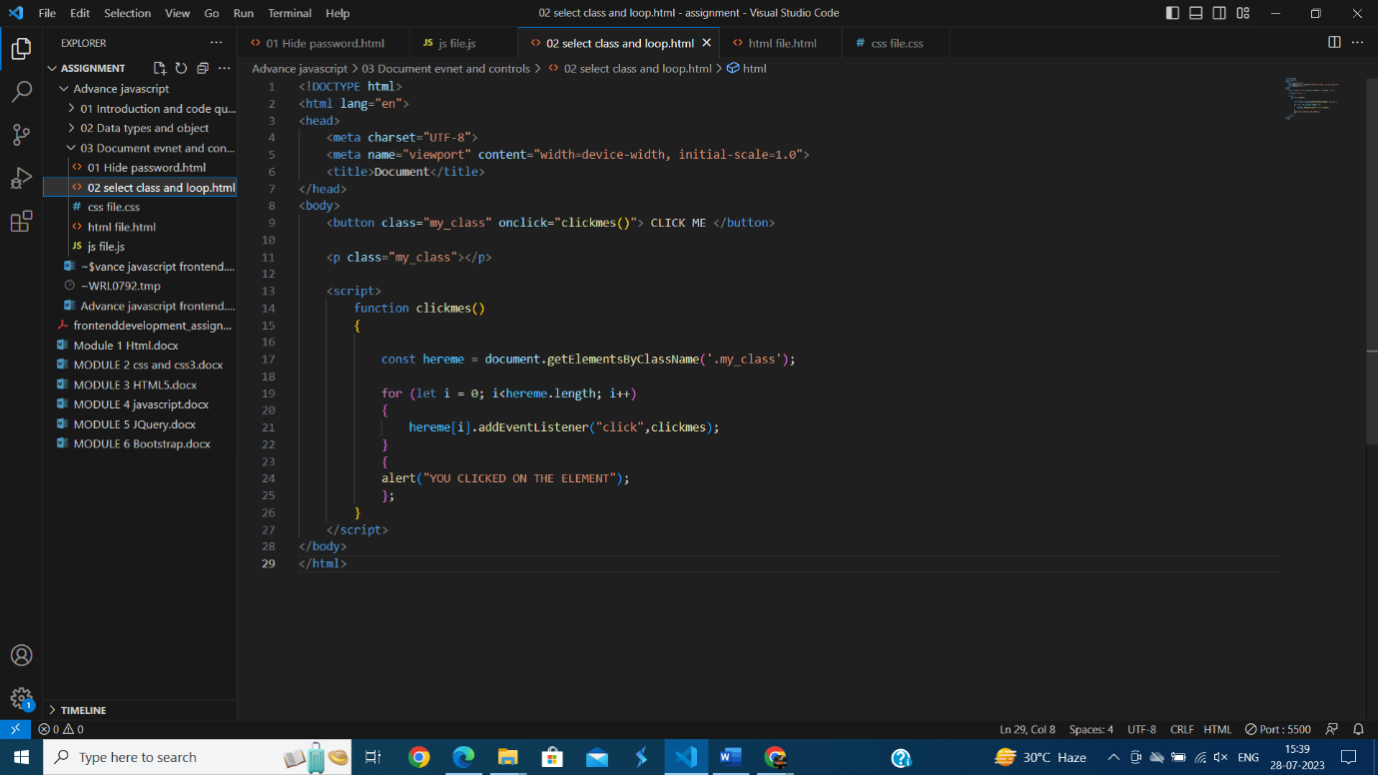

Q3 :- Create a responsive header using proper JavaScript.

Ans :-

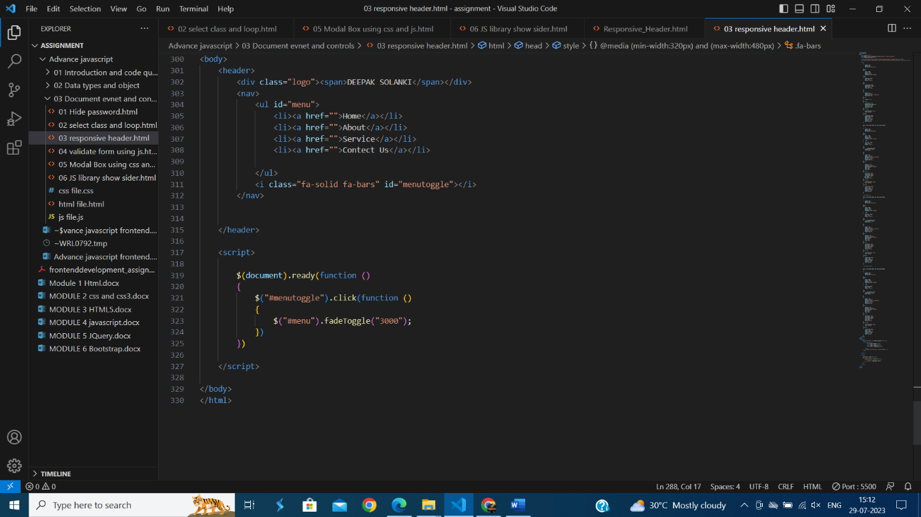

Q 4:- Create a form and validate using JavaScript.

Ans :-

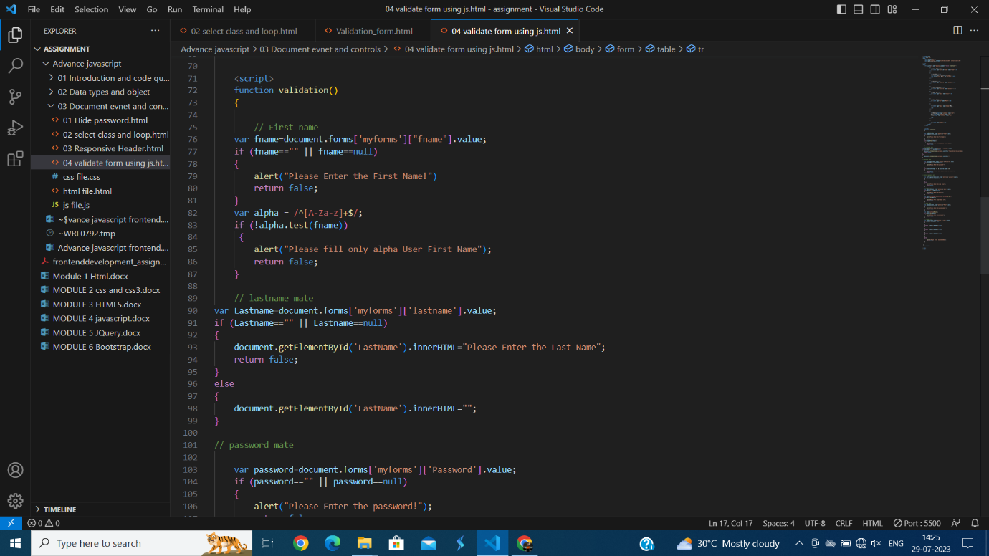

Q 5:- Create a modal box using css and Js with three buttons.

Ans :- 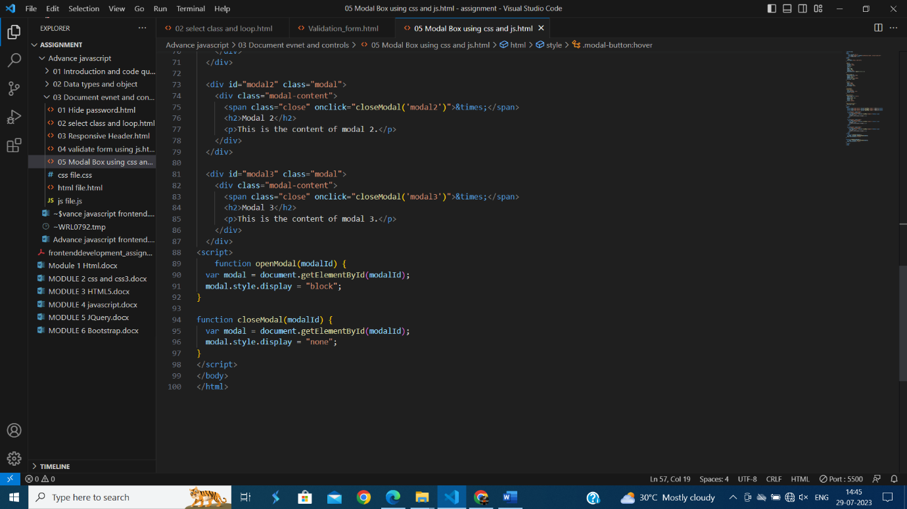

Q 6:- Use external js library to show slider.

Ans :-

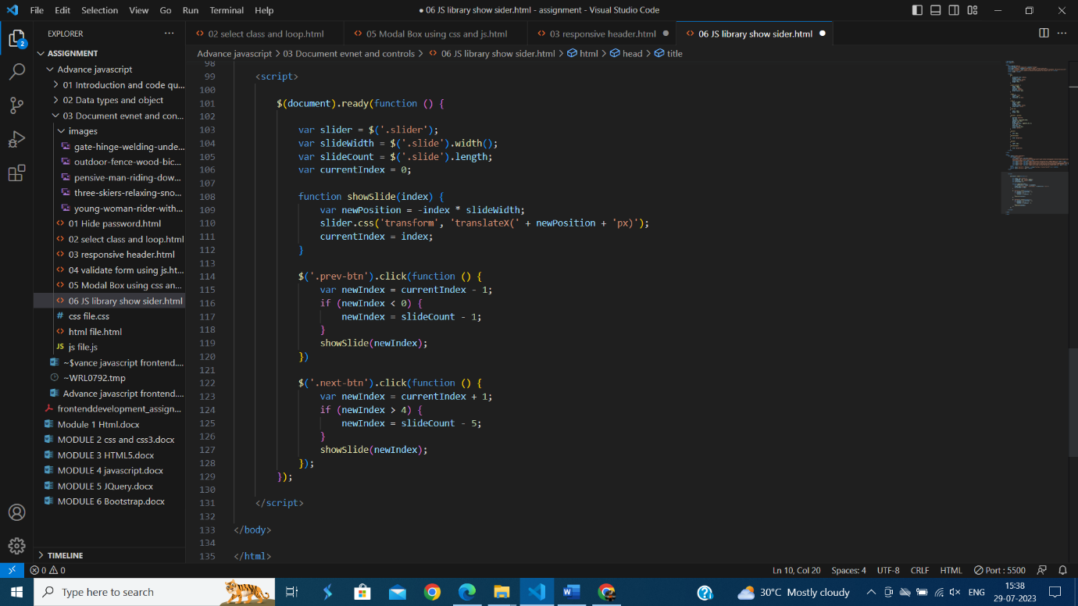

Q 7:- Prevent the browser when i click the form submit button

Ans :-

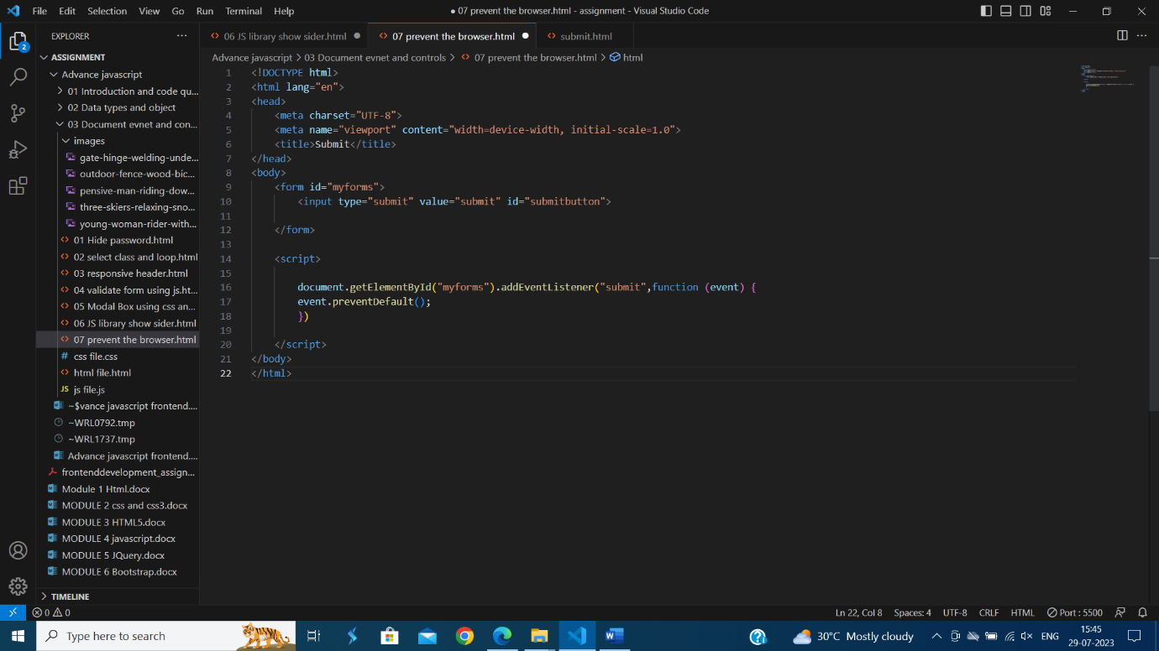

NEW REQUEST

Q1 :- What is JSON ?

Ans :- JSON stands for JavaScript Object Notation. JSON is a lightweight format for storing and transporting data. JSON is often used when data is sent from a server to a web page.

Q2 :- What is promises ?

Ans :- A promises represents a value that may not be available yet but will be resolve at some point in the future either successfully with a result or unsuccessfully with an error.

A promises can be in one of three states :-

1) pending

2)Fulfilled(success)

3)Rejected(unsuccess)

Q3 :- Write a program of promises and handle that promises also.

Ans :-

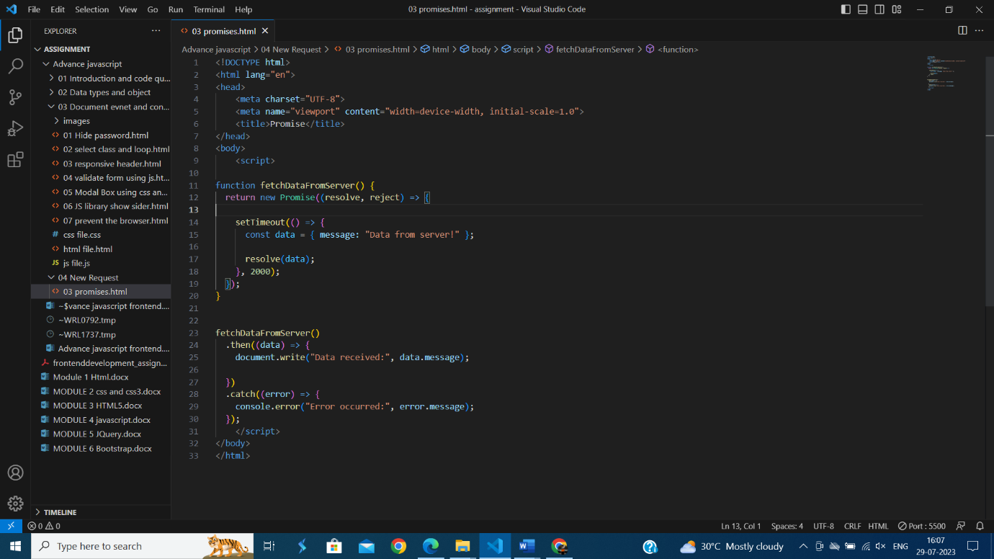

Q 4:- Use fetch method for calling an api <https://fakestoreapi.com/products>

Ans :-

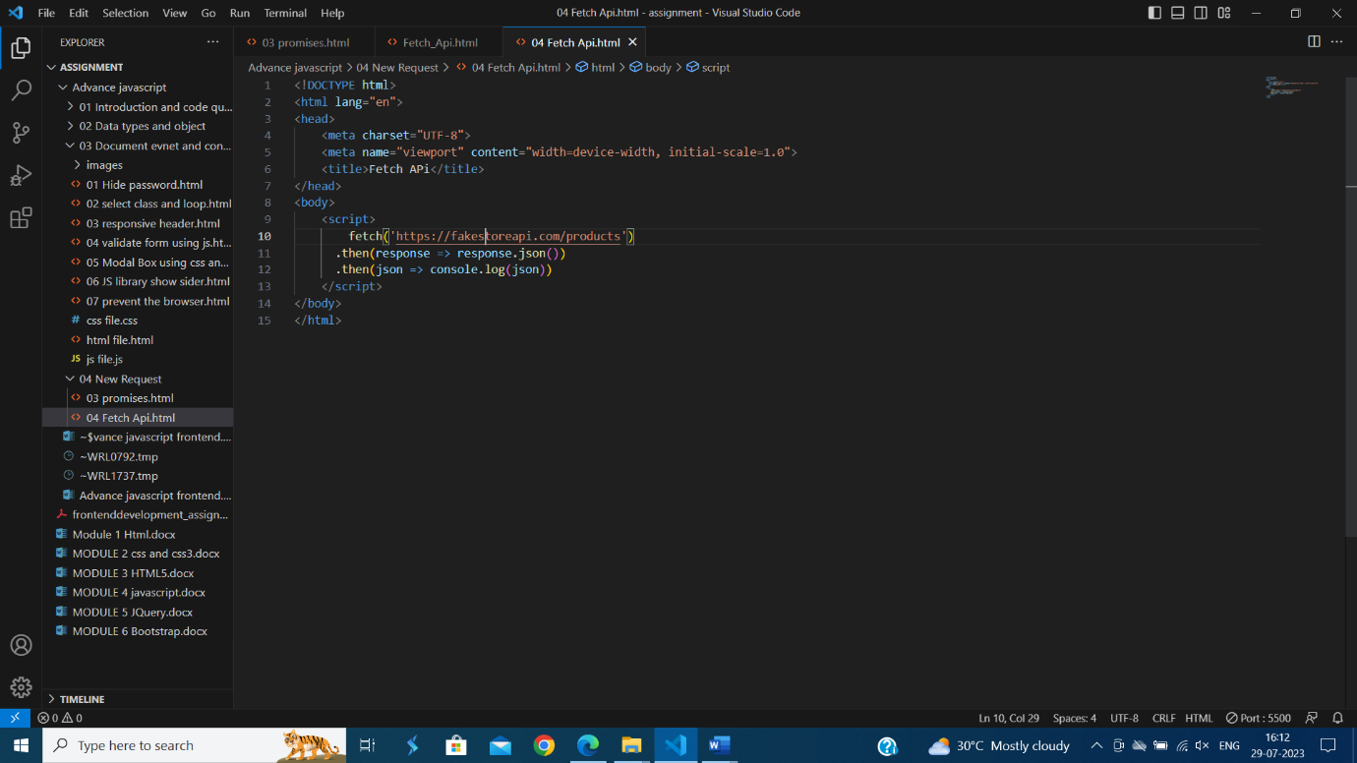

Q 5:- Display all the product from the api in your HTML page

Ans :-

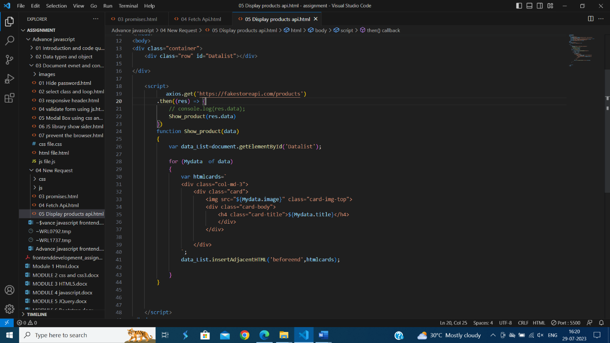

JAVASCRIPT ESSENTIALS

Q 1:- Calculate subtotal price of quantity in JavaScript?

Ans :-

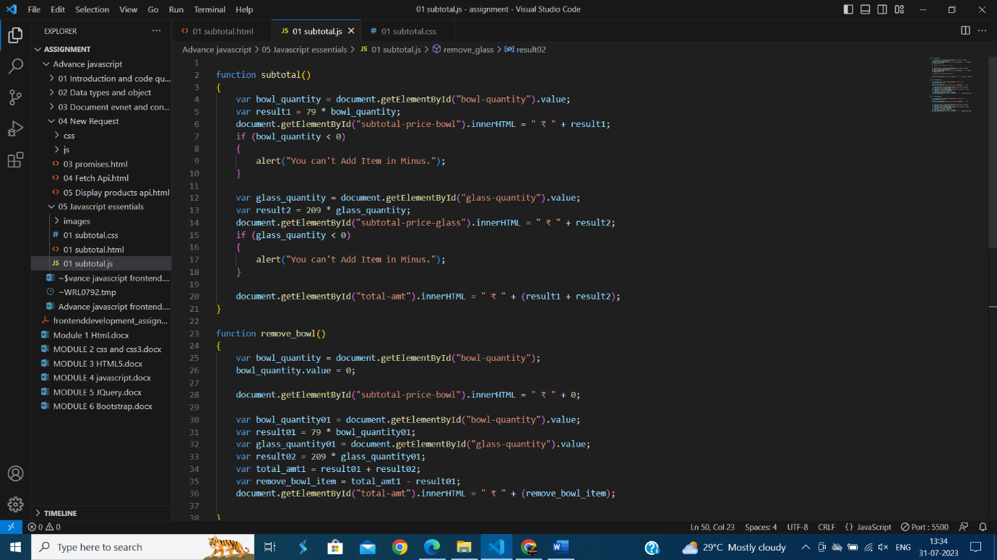

Q 2:- What is javascript output method ?

Ans :- JavaScript can "display" data in different ways:

Writing into an HTML element, using innerHTML .

Writing into the HTML output using document.write() .

Writing into an alert box, using window.alert() .

Writing into the browser console, using console.log() .

Q 3:- How to use Javascript Output Method ?

Ans :- 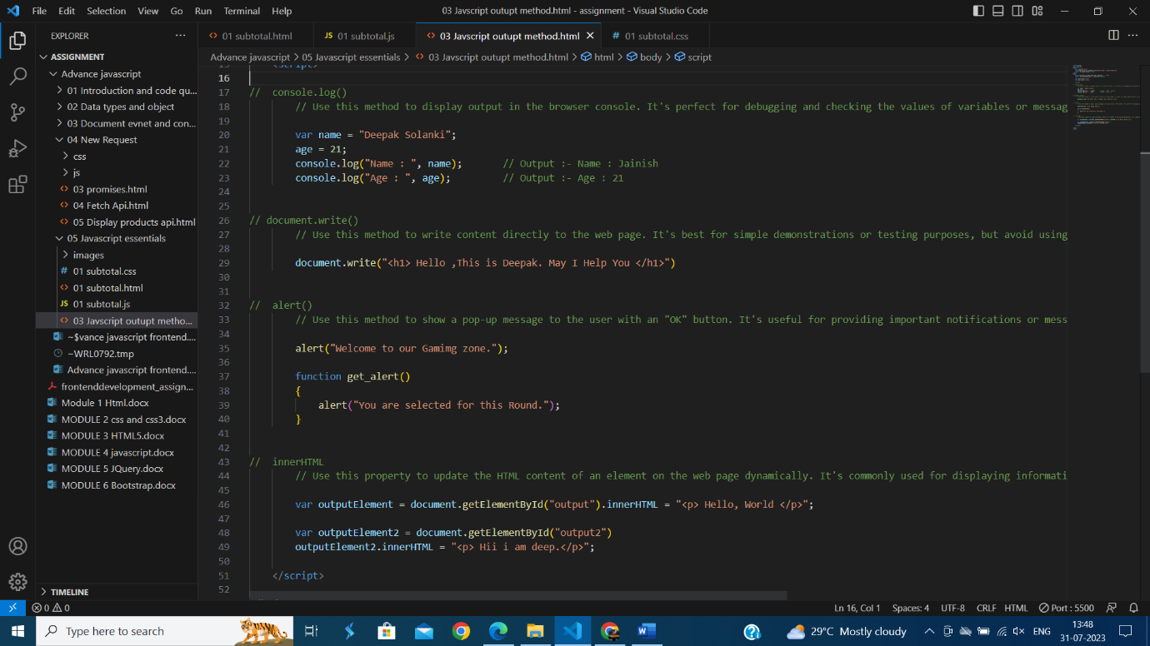

Q 4:- How to Used Javscript Events to do all Examples ?

Ans :-

